FREQUENTLY ASKED QUESTIONS
Q: When was the SIPmath Tool Bar last updated? A: 2/1/2017. The current version is 3.2.6.
Q: How do I install SIPmath in Excel..
Q: After following the install instructions for SIPmath, the menu doesn’t show in Excel
Q: I don’t see the SIPmath tab at the top of my screen after installing SIPmath.
Q: What is the difference between HDR, RAND and User when specifying a distribution.
Q: How can we compare multiple distributions?
Q: How can we compare the distribution of multiple alternatives?
Q: The triangular distribution doesn’t seem to generate any uncertainty.
Q: How can I see the different simulations?
Q: What is the Myerson distribution?
Q: How can I change the default number of bins in the histogram and cumulative distribution graph?
Q: I am unable to edit the Normal or the Uniform correlation equations?
Q: I want to email the model but it is too large to email. What is the best way to share the model?
Q: The lognormal distribution give me a “NUM#” error. What is wrong?
Q: The resample distribution option resamples with replacement. How can I resample without replacement?
Q: I cannot generate a graph. I receive an error message that the variable cannot be found.
Q: I want to eliminate the Sparkline on a RV.
Q: My Sparklines and Histograms disappeared.
Q: Having issues with Multiple Experiments.

Frequently Asked Question Answers
Q: How do I install SIPmath in Excel? I don’t see the SIPmath tab at the top of my screen after installing.
- A: The download from ProbabilityManagement.org only downloads the SIPmath tool. There are a few other steps that need to be taken to include it as an Excel ADDIN. Then it will be available all the time. Please see this video for details on the steps to take.

Q: After following the install instructions for SIPmath, the menu doesn’t show in Excel?
A: This may be related to a recent security change to Excel, discussed here. You may need to "unblock" the add-in(s) as follows:
Note This action cannot be undone.
- Locate the .xla or .xlam file in File Explorer.
- Right-click the file, and then click Properties.
- Click the General tab
- At the bottom of the dialog there may be an area labeled Security, with a checkbox labeled Unblock. Select the Unblock check box.
- Click Apply, and then click OK.
After you do this, the Excel add-in will be available and appear as expected. The Unblock check box will no longer appear in the properties dialogue box.

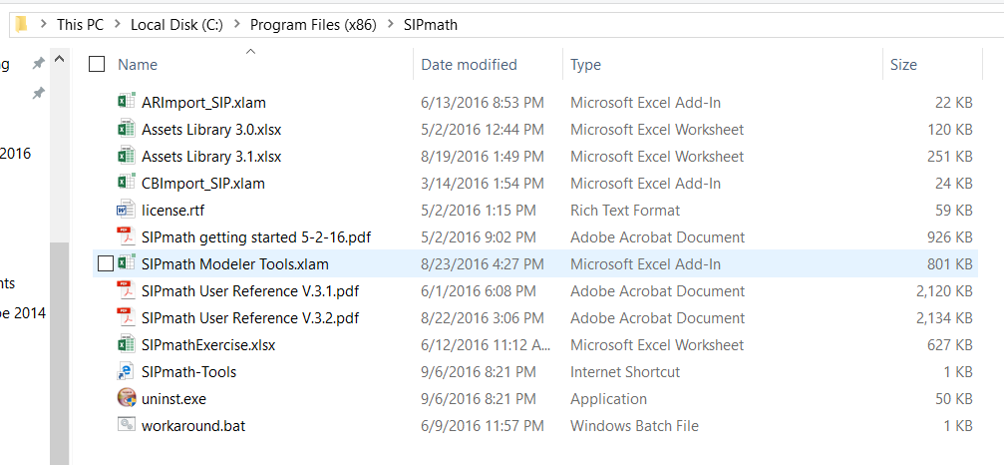
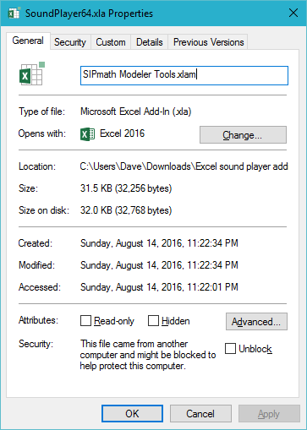

Q: What is the difference between HDR, RAND and User when specifying a distribution.
A: HDR Random Number
- The HDR random number option is an algorithm created by Hubbard Decision Research. It generates consistent but different random numbers for each simulation. If no “Start Variable ID” ( random seed) is specified, then a separate and unique Start Variable ID is assigned to each HDR making them independent.
- By specifying a Start Variable ID the user then has the option to try different values to see if the results are material different with different sets of random numbers. And if so the number of simulations can be increased until there is little difference.
- Alternatively, if more than one random variable has the same seed, they will be perfectly correlated.
Excel RAND() Function
- If the rand function is selected then the Excel RAND() function is used to generate the random variable.
- The disadvantage of this method is that the model will give slightly different answers each time it is calculated. With the HDR option the model will give the same probabilistic result. (Unless the Start Variable IDs are changed.)

User Variable
- If the “User” radial is marked, then the user can specify a single cell that represents the random number.
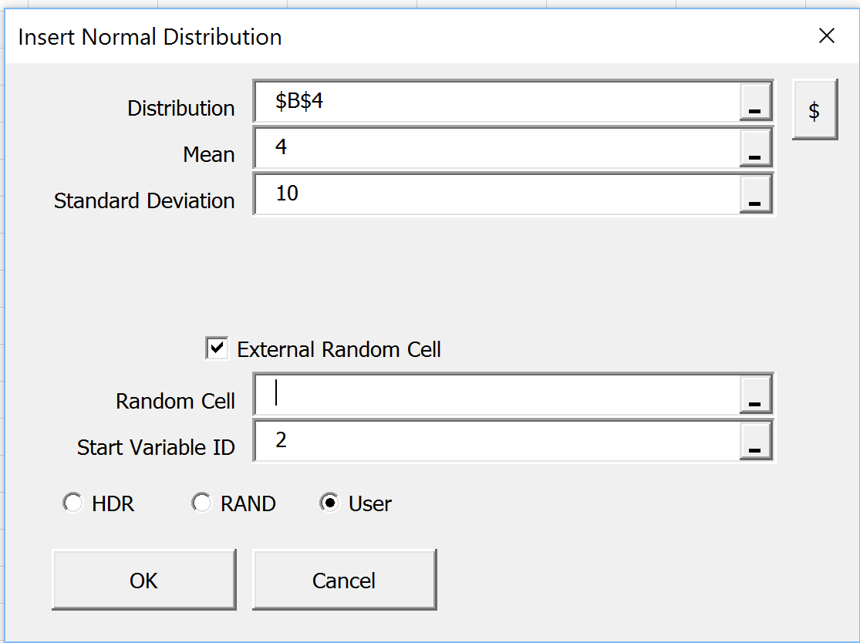
- Specify the Random cell. The Start Variable ID is ignored.

Q: How can we compare multiple distributions? How can we compare the distribution of multiple alternatives?
- Doing a proper probabilistic analysis generally requires comparing multiple distributions. Graphing these as histograms for comparison is difficult. The best way to compare them is by plotting cumulative distribution charts using an XY chart.
- This video shows how that can be done relatively easily.
  - Use the PERCENTILE command to generate percentiles. Suggest (.002, .01, .02….99, .998) for each of the output variables that we want to plot.
  - Best to do this on a separate worksheet within the model.

Q: The triangular distribution doesn’t seem to generate any uncertainty
A: The problem probably relates to the random variable cell specified when Generating the distribution. The default random variable is “User”. So if the “Random Cell (Required)” specified is blank there will be no uncertainty in the distribution unless the HDR or RAND radial is marked.

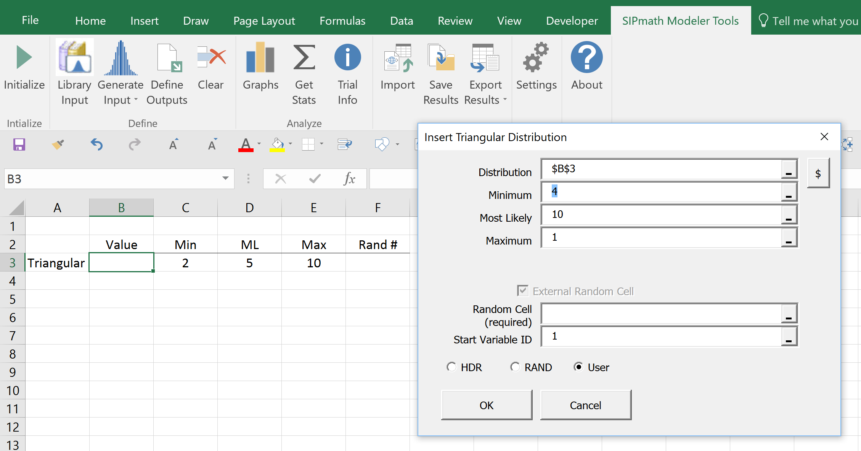

Q: How can I see the different simulations?
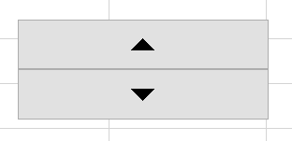
A: The Outputs of the simulations are in the datatable on the PMTable worksheet. But this probably contains 1000 or more simulations. To test the model we want to cycle through those simulations. We could just increment the variable PM_Index from 1,2, 3….. to see how the model is performing. But the easier way is to add a “Spinner” that is linked to the PM_Index variable. Each time the up or down arrow is clicked the PM_Index will change up or down by one allowing us to see many simulations very quickly.
- The spinner is added through the developers tab. This may need to be added to your menu bar by “File / Options / Customize Ribbon”
- On the Developer ribbon select “Insert” and then select the spinner Icon.
- Highlight a part of the worksheet to place the spinner.
- Right click on the spinner to specify the various parameters:
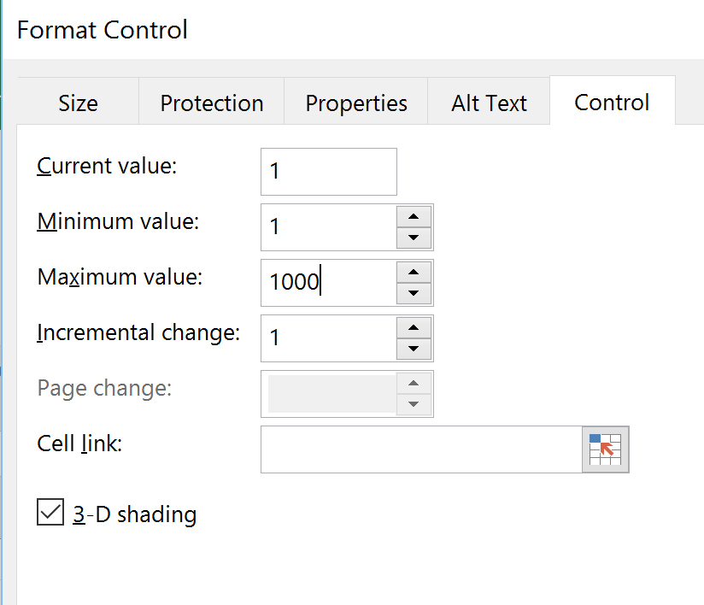
  - Current value (any integer)
  - Minimum value = 1
  - Maximum value = number of simulations specified
  - Incremental change = 1
  - Cell link should point to PM_Index

Q: What is the Myerson distribution?
A: The Myerson distribution, invented by Roger Myerson, is a generalization of both the Normal and Lognormal distributions, and can imitate either. If the 10th, 50th and 90th percentiles are evenly spaced (e.g. 3, 5, 7) then the distribution is a Normal distribution with the specified percentiles. If the percentiles increase geometrically (e.g. 1, 4, 16) then the distribution is a Lognormal. Other patterns will give intermediates between Normal and Lognormal.

Q: How can I change the default number of bins in the histogram and cumulative distribution graph?
A: Use the “Settings” icon to set the number of bins. The maximum number of bins is 100. The number of bins can also be changed on the SIPmath Chart Data worksheet. This applies only to the charts changed.

Q: I am unable to edit the correlated Normal or the Uniform equations?
A: The correlated Normal and Uniform equations use an Array Function. This is easily identified by “{“ around the equation. When editing the formula, rather than simply hitting return, you must use “Ctrl-Shift-Enter”. Using this command will put the Array Function symbols around the equation. If you do not do this the “{“ will not be there and the cell will probably indicate and error.

Q: I want to email the model but it is too large to email. What is the best way to share the model?
A: The model size is large probably because of the number of Output Variables and the number of simulations. To reduce the size of the model, “Initialize” the model to say only 100 iterations. If the model had been using 10,000 iterations this will reduce the size substantially. The recipient of the model can then “Initialize” back to 10,000 and have the exact same model. WARNING: No NOT “Reinitialize” as this will delete all of the Output variables in the model and they would have to be regenerated using the SIPmath Tool.

Q: The lognormal distribution gives me a “NUM#” error. What is wrong?
A: Check that the Percentile specified is between 0.6 and 0.99. The template may be pointing to a cell that has a number out of range.
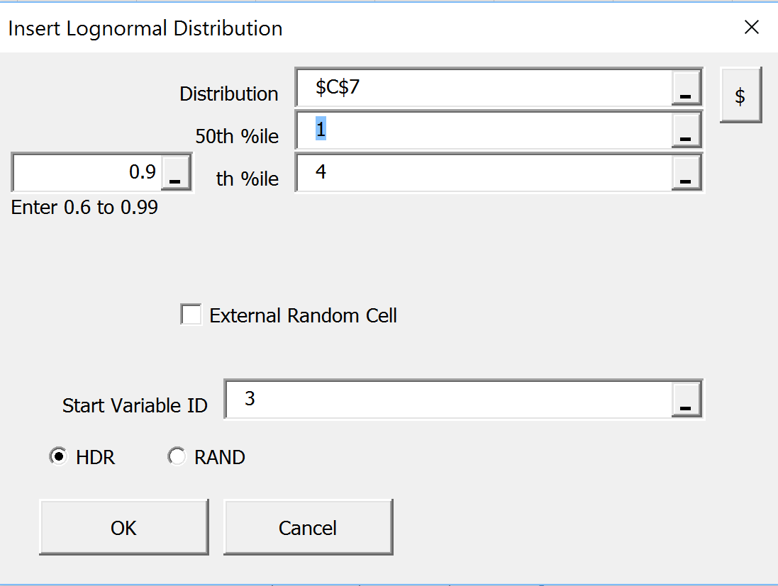

Q: The resample distribution option resamples with replacement. How can I resample without replacement?
A: Given a list of things (numbers or alpha numerics) assign a uniform distribution to each of the numbers (HDR uniform). Then use the Excel SMALL command to select as many numbers as needed for the sample. The first sample would be the smallest random number, the second sample the second smallest random number, etc. Below is a graphic showing the steps to select without replacement from the years 1995 to 2010 (Row 4). Rows 8-10 could be combined into one long formula, but are shown below for transparency.
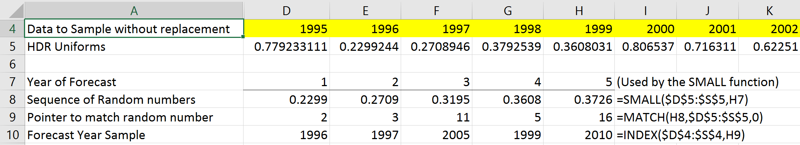
Each simulation will generate a new set of random number is Row 5 which will generate a new sampling of 5 years in Row 10 without replacement from the list of years in Row 4. .
Q: I cannot generate a graph. I receive an error message that the variable cannot be found.
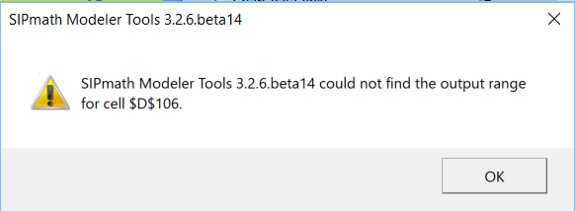
A: One possibility is that the range name originally defined for this variable was changed on the PMTable worksheet on row 2. The tool bar looks up the row by range name and not the link to the PMTable. To fix the error, identify the range name using Formulas / Name Manager and change the title on row 2.

Q: I want to eliminate the Sparkline on a RV.
A: If you have Sparklines that probably means you have defined it already as an Output Variable and it has a name. Rather than using SIPmath to delete the RV and do it over, simply use the Excel delete. Then regenerate the RV either using SIPmath or the equation that was originally there. When the cell calculates the results will be put back in the PMTable. You do not need to redefine it as an Output Variable. Doing this way, any graphs or other references to the RV will be in tack.

Q: My Sparklines and Histograms disappeared.
A: On the SIPmath Chart Data worksheet there is outlining. If the Histogram Data is not showing, click on the “2” near the top left corner of your screen. This should fix the problem.
Q: Having issues with Multiple Experiments.
A: Multiple Experimental Outputs is a little difficult to understand initially.
This Define Output Option is useful when it is desired to evaluate the distribution of a single value measure for an input variable. This is often called a sensitivity analysis. However, in this case the result is a probabilistic sensitivity as all input variables, other than the one being test for sensitivity, continue to be uncertain. In the example graphic below, we have generated two normal distributions that have a mean and standard deviation for inputs. The value measure we want to evaluate is the Sum of the two normal distributions. We want to see the impact of changing the Mean of Normal 1 on the metric Sum.
Multiple experiments is really just setting up a Two Way Data Table. This will replace the Data Table that might have been generated using Multiple Outputs. Any graphics associated with those variables will not be “live” any longer. You may wish to save a copy of the model before proceeding with Multiple Experiments or copy as values the PMTable worksheet and rename to save the current results.
The first entry in the template is the Output Name. This is the value measure you want to measure, perhaps it is NPV or capital spend. The Output Cell will be a cell with a calculation that depends on the Input variable, that is, the value measure of interest (Sum). The Input Name describes what variable will be changing. This might be product price, demand, cost of some element in the project. The Input Cell, a single cell, is what will be changed by the Two Way Data Table. The Input Values are the values that the Input Cell will take on. In this case we will examine the impact of the mean of Normal_1 taking on the values of 0, 1 and 2. Sparklines can be specified, but not required.
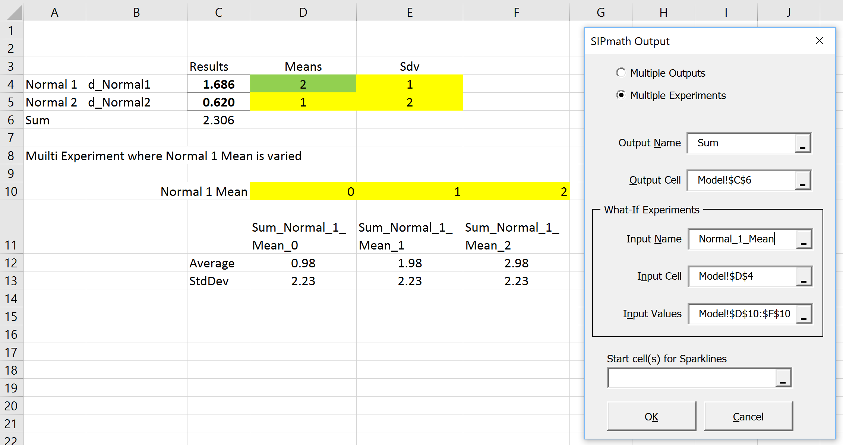
When we hit OK the Input Values are turned into distributions of the Output variable. That is to say, we can calculate the AVERAGE(D10) and use the Get Stats Icon to get the average of the Sum when Normal_1 has a mean of Zero. The Sum of N(0,1)+N(1,2) has a mean of 1 or 0.98 as shown in the example. Standard Deviation and other statistics on the SIP will also work.
What has happened is that SIPmath has generated a Two-Way Data Table with 3 columns (because we had 3 values for Normal_1 Mean). SIPmath has assigned an Output name which is the concatenation of 1) the Output Name 2) the Input Name and 3) the Input Variable value. The yellow cells are the PM_Index values that will drive all the uncertainties in the model, and the gold values are the Input Values that we specified. This data table is 1000 x 3 if we specified 1000 simulations. The Input Cell that we specified will now be linked to cell B2 which will take on the values of 0, 1, 2.
SIPmath shows the Output Names that were assigned to each of the SIPs on row 2. You may wish to copy these names underneath the Input values that were specified above to indicate that they are SIPs of the Output cell. (They are not SIPs of the input variable).
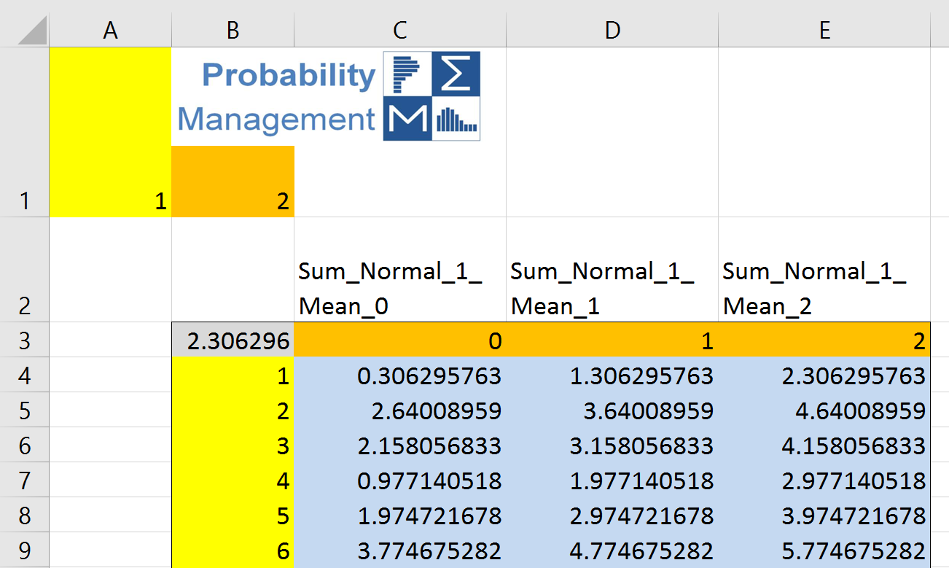

We can also generate graphs (histograms or CDFs) of the output value measure for each of the input values by selecting cells D10:F10. Below is a graphic showing the CDF for all three values for Normal_1_Mean.
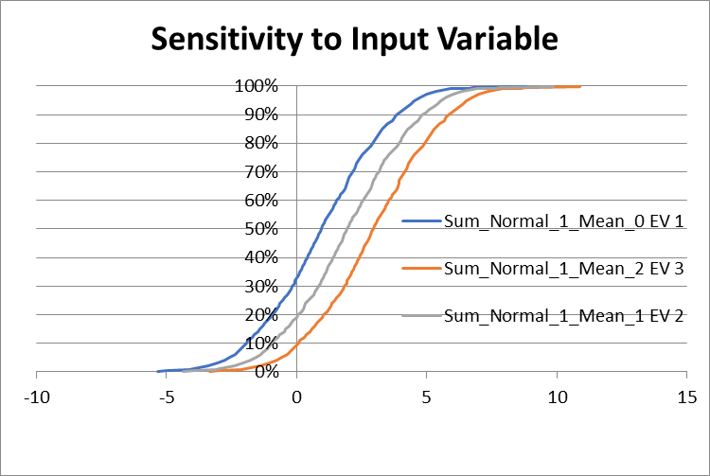
For more information on the Multiple Experiments watch this video.
https://www.youtube.com/watch?v=W9pU0PzCBZ8
There are also numerous other YouTube videos that explain Two Way Data Tables.

